Fractions and Red River Carts
Subject: Mathematics Creator: Alison Kimbley
Stand: Number Grade: 4
Content (topic)

Exploring Fractions
Outcomes  N 4.6: Demonstrate an understanding of fractions less than or equal to one by using concrete and pictorial representations to:  - Name and record fractions for the parts of a whole or a set.  - Compare and order fractions.  - Model and explain that for different wholes, two identical fractions may not represent the same quantity provide examples of where fractions are used. | Indicators  N 4.6a: Represent a fraction using concrete materials.  N 4.6b: Represent a fraction based on a symbolically concrete representation.  N 4.6f: Represent a fraction pictorially by indicating parts of a whole.
Mathematical Processes:
- Connections
- Communication
- Problem Solving
- Reasoning
- Visualization
Lesson Preparation
Equipment/materials:
- White paper
- Tape
- Worksheet

Advanced Preparation:
- Print off copies of the pdf version of Appendix 1.
- Teachers will need a copy of the Red River cart grid
Presentation
Development
- Remind the students of the history of the Red River cart and review the information from the PowerPoint. Ask students specific questions that relate to the history of the Red River cart. Some questions may include:
  - How did the Red River cart cross waterways? (Answer: The high wheels provide stability and could be removed and lashed to the bottom to form a raft and float across the waterway)
  - Where were the two materials the Red River cart was made of? (Answer: wood and leather)
- Show the students the photo in Appendix 2 and ask them to count the number of spokes. Explain to students that they are going to make model Red River cartwheels with different numbers of spokes.
- Give each student a copy the pdf version of Appendix 1. Have each student cut out the two rectangles on this sheet and then cut along the black lines to form 20 spokes.
- Have each student place 3 spokes on one of the wheels to divide the wheel into three equal parts (sectors). Ask the students what fraction of the wheel is represented by each part (1/3). Ask the students to show the fraction ½ using the spokes of the Red River cart.
- Clear the spokes from the wheel. Ask students to create their own fraction by putting a select number of spokes on the wheel. They will swap wheels with a partner and determine what fraction their peer has created on the wheel. Students can do a check with their peer to see if they are correct.

Appendix 1
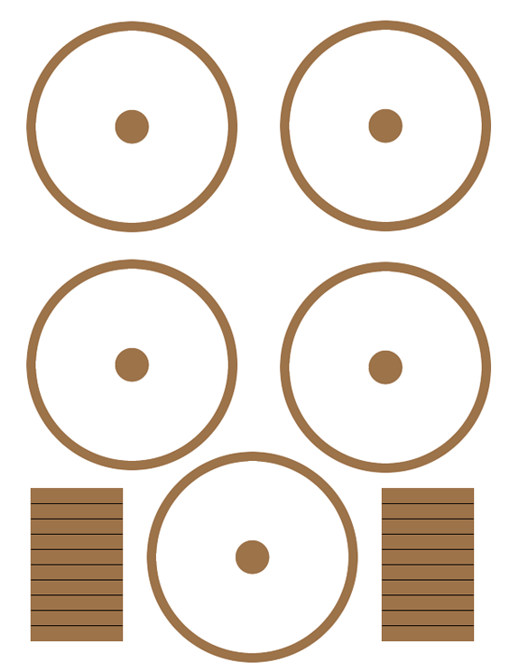Appendix 2

